 | 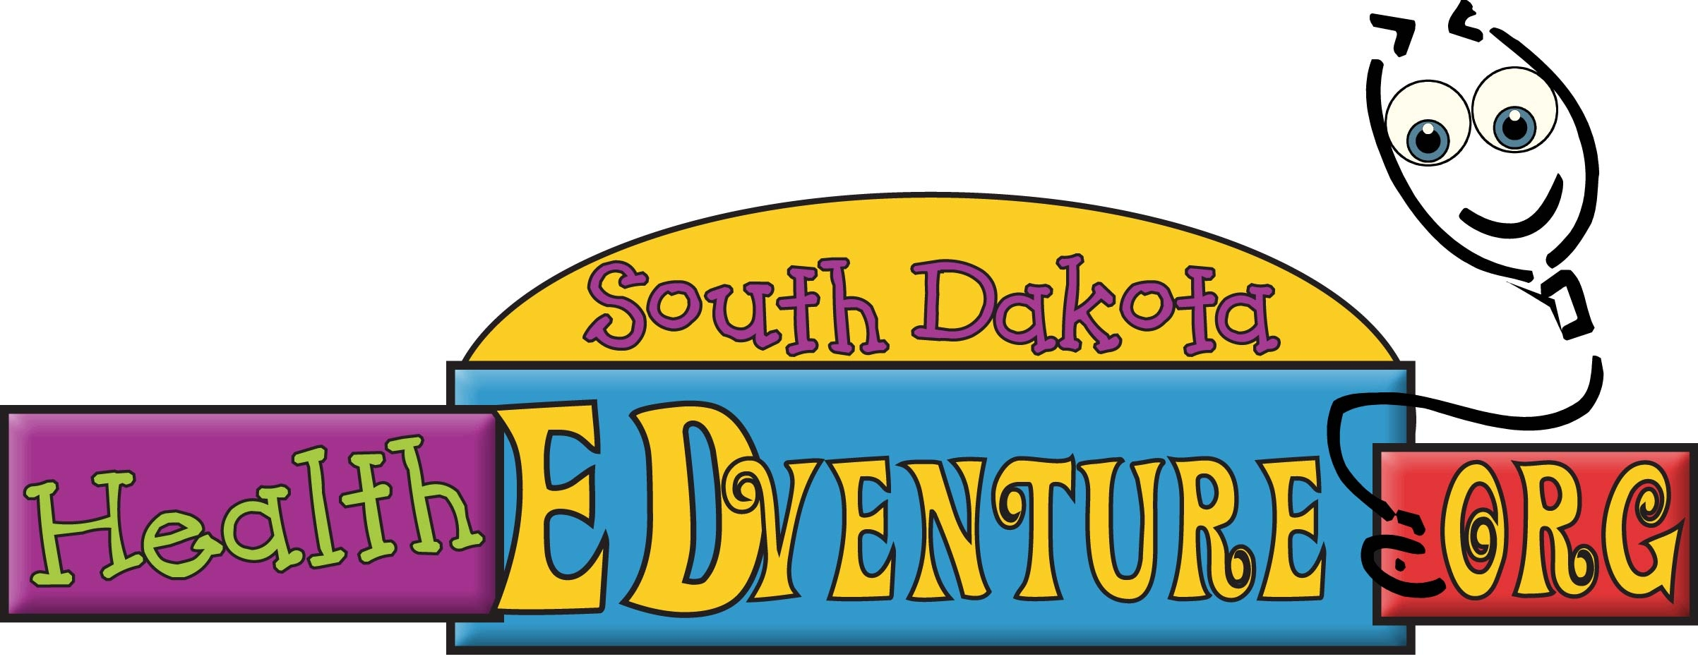
 | Check smoke alarms | Do 20 jumping jacks | Eat 2 fruits today | Turn off the TV today | Get 6 or 8 hours of sleep |  |  |  | Make your bed | Drink 4 glasses of water daily | Wash your hands before meals | Eat a healthy snack | No sweets today
 | Jump rope 50 times | Eat 3 meals a day | No video games today | Eat a healthy snack | Take a ½ mile walk |  |  |  | Wear Sunscreen | Clean your room | Wear a seatbelt | Drink 3 glasses of milk | Use insect repellant
 | Recycle one item | Read for 15 minutes |  | Ride your bike 1 mile | Eat 2 servings of protein |  |  |  | Get 6 or 8 hours of sleep | Wear a helmet when riding your bike |  | Brush your teeth twice daily | Play outside for 30 minutes
 | Wear a seatbelt | Drink 4 glasses of water daily | Walk around the block | Make your bed | Eat a red fruit |  |  |  | Eat 1 vegetable | Do 10 pushups | Walk around the block | Floss your teeth | Read for 15 minutes
 | Set the table for dinner | Clean your room | Drink juice instead of soda | Eat an orange vegetable | Use insect repellant |  |  |  | Play a game with your family | Try a new fruit or vegetable | Set the table for dinner | Shower or bathe each day | Jump rope 50 times

 | Do 10 pushups |  | Wash your hands before meals |  | Make your bed |  | Help cook a meal |  | Eat 3 meals a day |  |  |  | Turn off the TV today | Set the table for dinner | Recycle one item | Go swimming | Drink juice instead of soda
 | Brush your teeth twice daily |  | Clean your room |  | Eat 2 servings of protein |  | No video games today |  | Play outside for 30 minutes |  |  |  | Eat an orange vegetable | Eat a red fruit | Do 10 pushups | No sweets today | Get 6 or 8 hours of sleep
 | Try a new fruit or vegetable |  | Eat an orange vegetable |  |  |  | Wear sunscreen |  | Eat 2 fruits today |  |  |  | Eat 1 vegetable | Brush your teeth twice daily |  | Eat a healthy snack | Check smoke alarms
 | Turn off the TV today |  | Floss your teeth |  | Go swimming |  | Drink 3 glasses of milk |  | Do 20 jumping jacks |  |  |  | Help cook a meal | Floss your teeth | Take a ½ mile walk | Drink 3 glasses of milk | Ride your bike 1 mile
 | Eat a red fruit |  | Shower or bathe each day |  | Wear a seatbelt |  | Take a ½ mile walk |  | Read for 15 minutes |  |  |  | Eat 2 fruits today | Play a game with your family | Wear a helmet when riding you bike | Walk around the block | Shower or bathe each day

