Using the pictures below, write a story about a character who is experimenting with tobacco, including how that character feels. Then, add another character who is helping the experimenter say “no” to tobacco and how he/she feels after saying “no.” Be creative! ☺

Your first number is the character in your story who is experimenting with tobacco.
1 – A skier  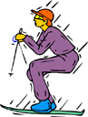 | 2 – A ballerina   | 3 – A golfer | 4 – A camper | 5 – A student  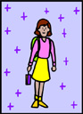

Your second number is a feeling that tobacco may cause the experimenter in your story to feel.
1 – Feeling sad   | 2 – Feeling like there is no one to talk to | 3 – Feeling sick   | 4 – Feeling mean | 5 – Feeling anxious

Your third number is the tobacco-free character(s) in your story who are helping the experimenter choose to NOT use tobacco.
1 – A teacher   | 2 – A doctor | 3 – A dentist  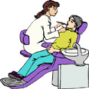 | 4 – A veterinarian  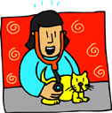 | 5 – An elderly couple  